Macroeconomics. Test – 3. Total – 25 points. Total time: 80 minutes. Answer all 5 questions.
Part I. Fiscal policy
Problem – 1. (5 points)
- Explain Keynesian equilibrium (you have to draw a graph and show the equilibrium). 1 points
It is a macroeconomics equilibrium state identified by the Keynesian model of the opposing aggregate expenditure forces. Equal aggregate production achieve a balance with no coherent tendency for change as illustrated below.
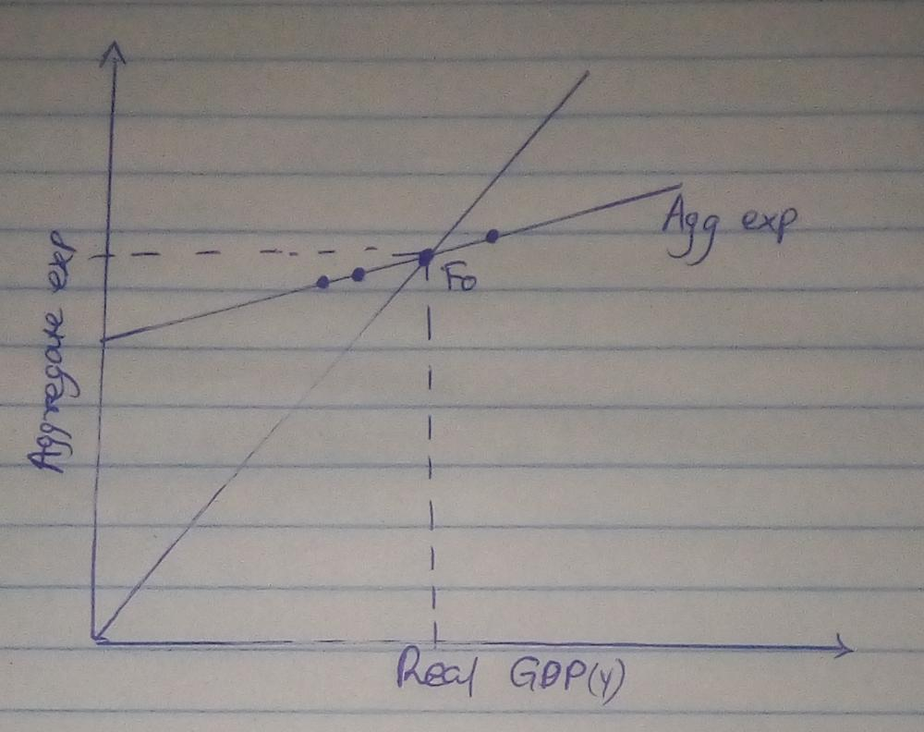
Explain (in words, not in terms of mathematics) the following consumption function: 2 point

C = 100 + 0.65 (Y – T)
This is a consumption function where 100 is autonomous consumption, 0.65 is the marginal propensity to consume and Yd is the disposable income after tax. Yd = Y-T, where Y is the national income and T is tax. It is used to determine the economic events and policy actions will affect the real GDP.

- Use the following graph to answer the next question: 2 points
AE = Y
AE
AE₁

Y (Real GDP)
Y₂
Y₁
Y₃

If Real GDP is at Y₁ how producers will respond (explain in terms of inventories and production)?
Y1- if the price level decreases, the aggregate planned expenditure exceeds the real GDP and therefore the firm’s inventories are smaller than planned.

If Real GDP is at Y₃ how producers will respond (explain in terms of inventories and production)?
The Y3 will increase by one.

SEE NEXT PAGE FOR QS. 2- 5

Problem – 2. (9 points)
Suppose the Canadian economy can be described as follows:
C = 200 + 0.8 Y_{d} (Y_{d} is disposable income)
I = 165 (investment spending)
G = 410 (government purchases)
T = 0.25Y (proportional taxes)
X=45 (exports are constant)
M =0.1Y (imports depend positively on our own Y)
- Calculate the equilibrium Y. 3 points
- Find the government budget balance BB=tY-G, given your Y in (i). Is the government running a surplus or deficit or neither? 2 points

iii) Now, let’s look at the consumption function C = 200 + 0.8 Y_{d} (Y_{d} is disposable income), where 200 was defined as autonomous part of the consumption expenditure. Let’s say the autonomous consumption expenditure drops from 200 to 150. Find the new Y. 2 points
- Find the government budget balance, given your Y in (iii). Is the government running a surplus or deficit or neither? 1 points

- If there is a budget deficit (specifically, when the GDP is low/economic downturn), should government continue to run a budget deficit or decrease the government spending and balance the budget? Explain. 1point

Problem – 3. (4 points)
- Explain contractionary fiscal policy: Use a graph & explain. 2 pts
This is a case where the government decides either to raise its expenditure or cut the spending. As a result, it lowers the flow of money available for expenditure by the consumers and businesses.
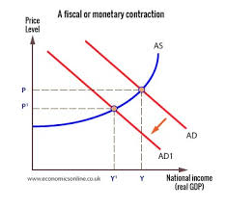
- Explain expansionary fiscal policy: Use a graph & explain. 2 pts
Expansionary fiscal policy incorporates payments transfer, tax cuts, rebands and government increased expenditure on projects like improvements of the infrastructure. For instance, it can raise discretionary spending by the government, economy infusion with more money by contracts by the government.
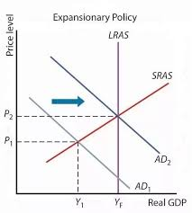
Part II. Monetary policy.
Problem – 4. 3 points
- Explain the monetary policy to increase money supply (you need to explain those tools we discuss in the class)? 2 points
Lowering of the bank’s reserve requirement enhances the bank to lend more. The federal Reserve board points paper currency at its discretion in an effort to increase the amount of money in the economy. The tools include lowering of the interest rates and lowering of the reserve requirements by banks.
- Explain the monetary policy to decrease money supply? 1 point
The monetary policy that decreases the money supply is the contractionary monetary policy. The money supply decrease is mirrored by an equal decrease in the nominal output which is also referred to as the Gross Domestic Product.

Problem – 5. 5 points
- What is “Bank Rate”, and “Overnight Rate”? 1
- What is “reserve ratio”? 1 pt
- Explain chartered banks’ money creation procedure. Explain with example. 2 pts

